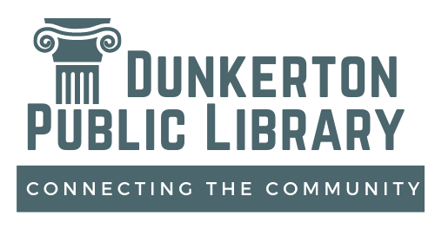

Dunkerton Public Library
2023 ~ 2027
Strategic Plan

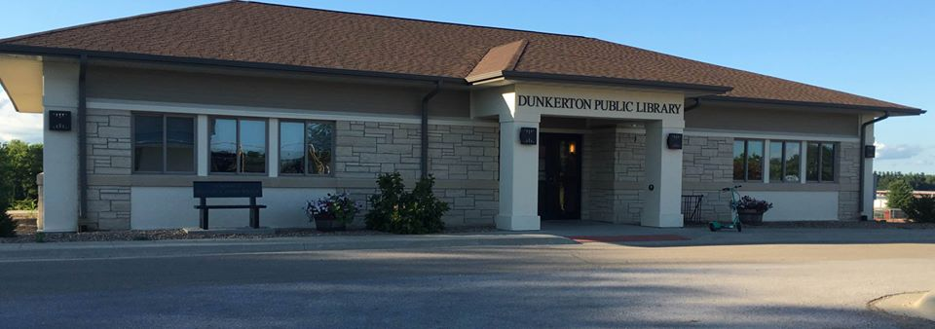

Approved by the Dunkerton Public Library Board of Trustees April 30, 2023

Connecting Our Community…

Library Board of Trustees

Curt Thomas, President
Kent Sommerlot, Vice President
Ronda Rathe, Secretary
Sue Koppmann
Melanie Stickfort

Library Employees

Michelle Wheeler, Director
Ashley Garbes, Assistant Librarian
Kennadi Neil, Assistant Librarian

Friends of the Library
Jessica Toneff, President
Julie Magee, Vice President
Paula Winkers, Secretary
Bruce Jefferson
Cassie Sage

The Dunkerton Community

Dunkerton is located in Black Hawk County in Northeast Iowa. It has four parks ( Charma Park, Eagle Scout Park, Gazebo Park, and Carol Hauptly Park) plus a walking trail. It also has the Mixdorf Nature Preserve, the Dunkerton Sportsman’s Club, the Community Hall, the Dunkerton Veterans Memorial Park, the Dunkerton Public Library, the community garden, a Dunkerton History Museum, and the Dunkerton Community School. The community has an active Women’s Club, 4-H Club, and the newly formed Dunkerton Historical and Tourism Association. Helping our city gain and retain residents is important for Dunkerton to thrive and to keep our school unconsolidated. A caveat is achieving growth without losing the positive aspects of being a quiet, small rural town. The comparison of the 2010 Census data to the 2020 data indicates some significant trends:
2010 Census 2020 Census
Total Population 852 842
Population, Percent under 18* 29.1% 23.1%
Population, Percent over 65 10.8% 16.7%
Households 327 320
Households with children under 18 38.2% 30.4%
Housing units 338 357
*Note: in 2000 Households with children under 18 was 41.6%.
This comparison shows that our community is aging and the number of families raising their children in Dunkerton has decreased. This is despite the increase in housing units. The 2020 Census shows that 5% of our population is in poverty and 15.3% are disabled – two aspects we must be sensitive to when planning.
As we realized our role in the community was changing, we adopted a new logo in October of 2020, changing from “The Pillar of Our Community” to “Connecting the Community”. The Community Conversation that we conducted in October of 2021 and the survey that was conducted in April of 2022 also aided the planning process.

Our Mission Statement

The Dunkerton Public Library will enrich our community serving as a hub to provide resources and services needed for life-long learning and leisure activities.

Build Community

GOAL: To be a gathering place where community members can connect.
Objectives:
- To increase utilization of the program room by community members, increasing by a new usage monthly.
  - Utilize an online reservation process that will show the dates the room is available by the end of FY24.
  - Promote the Program Room to local organizations annually.
- To increase the count of patron visits by 5% each year through 2027.
  - To offer programs that facilitate togetherness and conversation by all who attend.
  - Increase frequency and visibility of online promotional material from the current event driven to a daily presence by 2027.
  - Increase the number of monthly free activities to remove the cost barrier.

GOAL: To be involved in our community.
Objectives:
- To attend community events consistently quarterly (the minimum) by the end of 2024.
- To increase collaboration with community organizations by participating in their activities and including them in library events.
  - Plan an event with a community organization annually.

GOAL: To be accessible to all in the community.
Objectives:
- To identify and remove barriers that may hinder use of the library.
  - Keep the library safe and updated.
    - Review ADA requirements every 3 years.
    - Replace the library’s outdoor lights by the end of 2023.
  - Staff to take annual CE classes on safety, accessibility, and inclusion.
  - Keep large print titles and audio books updated as budget allows.

GOAL: To be an asset to our community.
Objectives:
- Facilitate productive, positive communication aimed at helping our community thrive.
  - Director will attend City Council meetings monthly, representing the library to city leaders and keeping council members informed.
  - Director will be a liaison with the Dunkerton Historical & Tourism Association
    - Attend monthly DHTA board meetings.
    - Encourage and promote visits to the Dunkerton Museum in the lower level of the library.
- Provide in-person services and reliable online resources for free.
  - Annually review relevancy of online service and cost effectiveness.
  - Review annually the relevancy of in-person services and cost effectiveness.
    - Director will become a notary by the end of 2024.

Foster Lifelong Learning

GOAL: To promote literacy to all ages.
Objectives:
- Expand the book club program to include a teen and/or youth book club in addition to the adult book club by 2025.
- To begin a1,000 books before Kindergarten program by 2026.
- To increase enrollment in the Dolly Parton’s Imagination Library by 5% each year.
- To increase teen enrollment in the summer reading program by 10% each year.

GOAL: To provide relevant materials.
Objectives:
- In FY 24, improve upon the 3-year 3% average and begin consistently weeding 3% annually.
  - Remove dated, damaged, poorly circulated items.
- Keep nonfiction collection reliable and accurate by reviewing the collection bi-annually and replacing out-of-date items.
- Monthly review and purchase items per patron’s requests, the current best sellers list, trade journals, and CE class information.

GOAL: To provide essential internet, software, and hardware.
Objectives:
- Acquire an additional AWE station by 2025.
  - Seek funding through grants.
- Update technology replacement plan by 2024.

GOAL: To provide access to local history.
Objective:
- Increase Museum visits by 10% monthly.
  - Promote collection on our website and social media.
  - Verbally promote and suggest visits to patrons when they visit.
- Work with the Dunkerton Historical & Tourism Association to create a long-term solution by the end of 2024 regarding museum visits in light of library staff limitations.

GOAL: To facilitate learning opportunities.
Objective:
- Beginning in 2024, consistently plan a quarterly learning program or activity for adults and teens.
- By FY2025, consistently provide a monthly STEAM activity for youth.
- Increase usage of the library’s online learning services by 10% annually.

Provide Leisure Activities

GOAL: To provide enjoyable activities for the community.
Objective:
- Provide easy to attend activities with broad appeal
  - By FY2025, provide a new passive program quarterly.
  - Provide family-friendly events and activities weekly for the summer reading program and monthly during the school year.
- Increase program attendance 5% annually.
  - Seek input from community members and patrons when scheduling events and activities.
  - Seek feedback after events and activities to continually improve upon what’s is being offered and the patron’s experience.
  - Plan library events around school and other community events when possible.

