July
2022 | 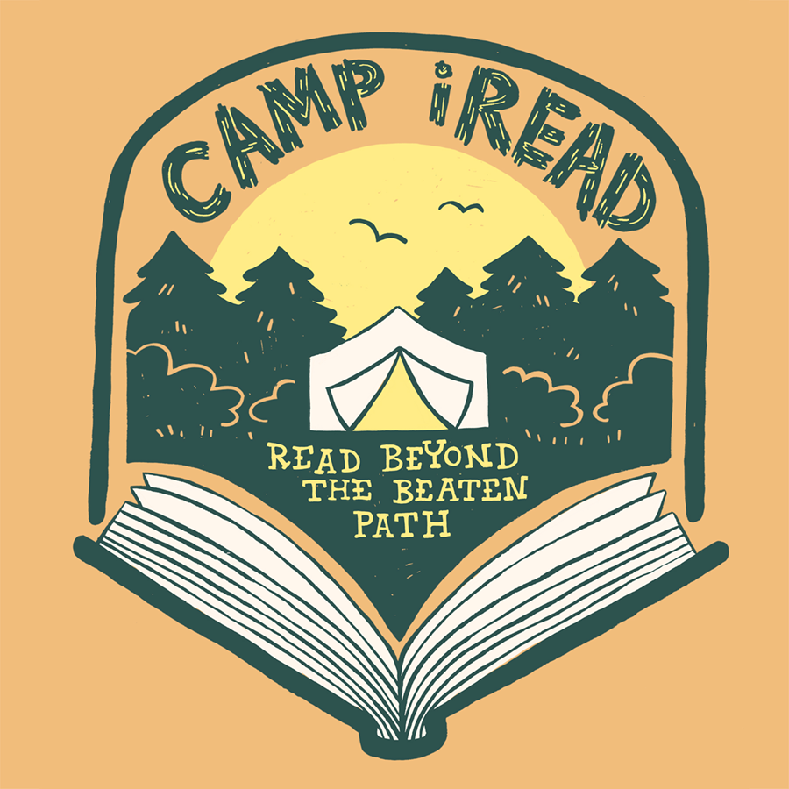
Dunkerton Public Library’s Summer Reading Program Calendar
Sunday | Monday | Tuesday | Wednesday | Thursday | Friday | Saturday
 |  |  |  |  | 1 | 2
10:30 – Noon
Lego Club

3 | 4 | 5 | 6 | 7 | 8 | 9
 |  |  | 9:30 AM  Story Time |  | Dusk-Outdoor Movie: The Boss Baby: Family Business | 10:30 – Noon  Lego Club
10 | 11 | 12 | 13 | 14 | 15 | 16
 |  |  | 9:30 AM  Story Time | *6:30 PM Jen Loeb -Mt. Climber |  | Dunkerton Days (library closed)
17 | 18 | 19 | 20 | 21 | 22 | 23
 |  |  | 9:30 AM  Story Time | **  3:00 PM  Boat Building Craft (sign up required) | ***  Dusk-Outdoor Movie: The Bad Guys | 10:30 – Noon  Lego Club
24 | 25 | 26 | 27 | 28 | 29 | 30
 |  |  | 9:30 AM  Story Time |  |  | 10:30 – Noon  Lego Club
31
Last day to log minutes! Reading Logs must be turned in by Aug. 3rd. | For Adults/Teens: | *6:30 PM Jen Loeb -Mt. Climber | **6:30 PM Book Club Discussion: A Study in Charlotte | ***2:15 PM Book Club Discussion: A Study in Charlotte

