June
2022 | 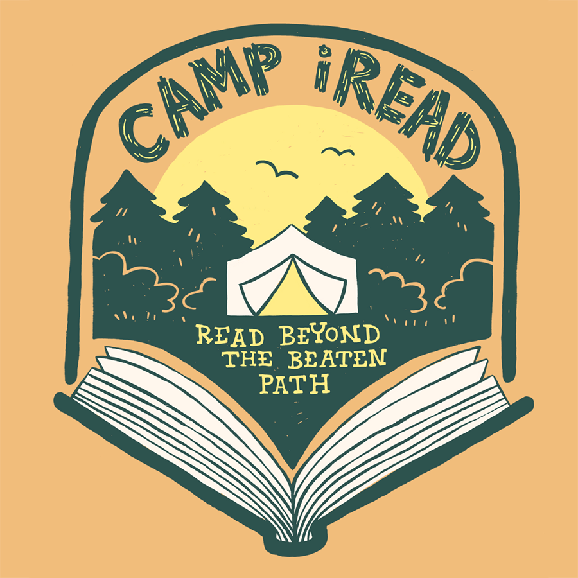
Dunkerton Public Library’s Summer Reading Program Calendar
Sunday | Monday | Tuesday | Wednesday | Thursday | Friday | Saturday
 | 2PM-6PM | 10AM-2PM | 1 | 2 | 3 | 4
HOURS: | Monday  Tuesday  Thursday | Wednesday  Friday  Saturday | Library Book Sale  Story Time 9:30 | Library Book Sale | Library Book Sale  Dusk- Outdoor Movie: Sing 2 | Library Book Sale  City-wide Garage Sale
5 | 6 | 7 | 8 | 9 | 10 | 11
 |  |  | Story Time 9:30 | *Bob Thurman-Grand Canyon 6:30PM |  | Lego Club  10:00-Noon
12 | 13 | 14 | 15 | 16 | 17 | 18
 | Magic Show  1:00 PM |  | Story Time 9:30 | ** | ***  Dusk-Outdoor Movie: Encanto | Lego Club  10:00-Noon
19 | 20 | 21 | 22 | 23 | 24 | 25
 |  |  | Story Time 9:30 |  |  | Lego Club  10:00 – Noon
26 | 27 | 28 | 29 | 30
 |  | SOAR:  Eagle Visit  4:00 PM | Story Time 9:30
For Adults/Teens: | *6:30 PM Bob Thurman- Grand Canyon | **6:30 PM Book Club Discussion: Where the Crawdads Sing | ***2:15 PM Book Club Discussion: Where the Crawdads Sing

